NAME :D.PADMA SREE
DATE:05.10.2026
COURSE CODE:CSA0618
COURSE:DAA
Experiment 1: Linear Search (Iterative)
a = [10, 25, 30, 45, 50]
key = 30

for i in range(len(a)):
if a[i] == key:
print("Key found at index", i)
break
OUTPUT:
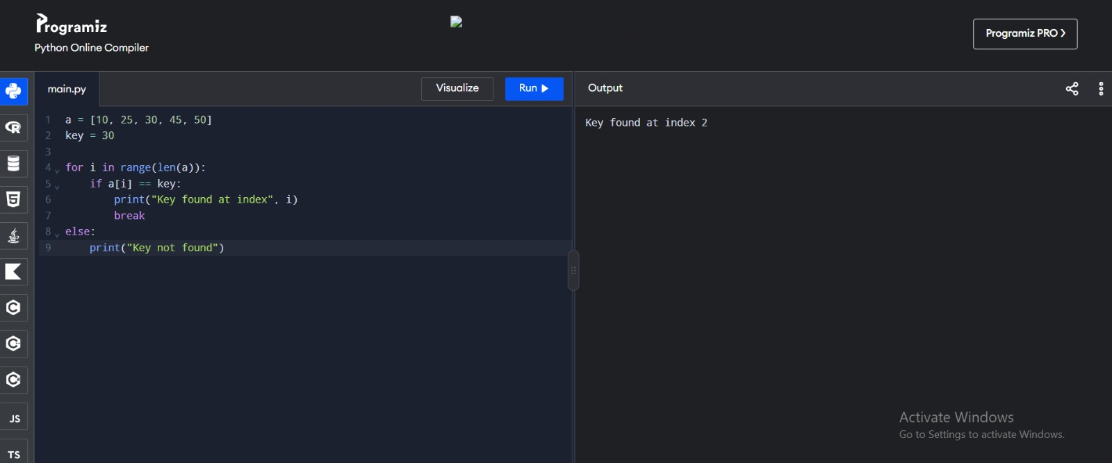
Experiment 2: Binary Search (Recursive)
def search(a, l, r, k):
if l > r:
return -1
m = (l + r) // 2
if a[m] == k:
return m
if k < a[m]:
return search(a, l, m-1, k)
return search(a, m+1, r, k)

a = [5, 10, 15, 20, 25]
print("Key found at index", search(a, 0, len(a)-1, 20))
OUTPUT:
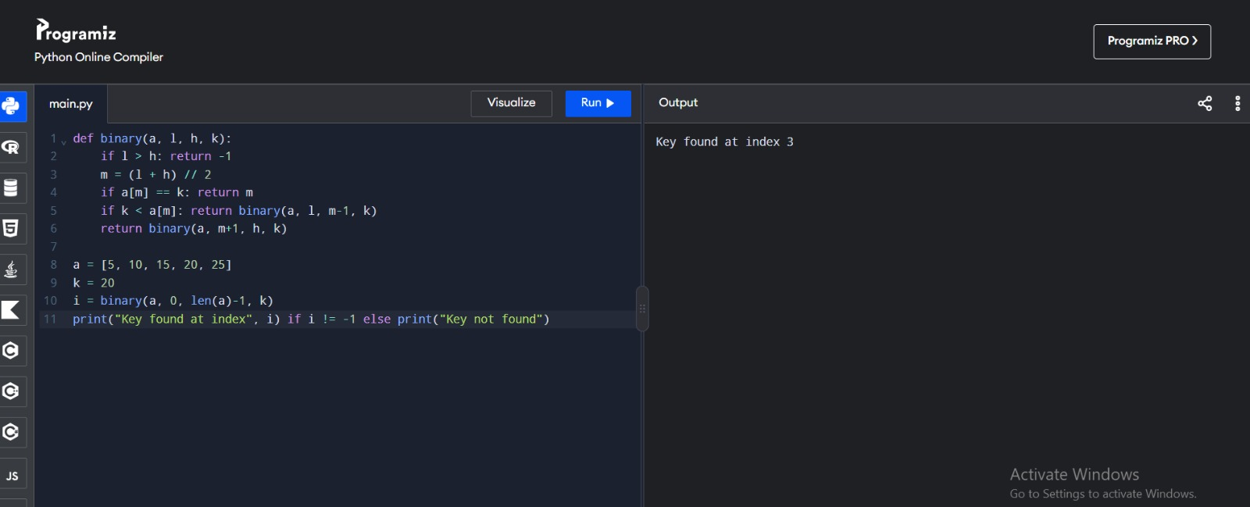
Experiment 3: Factorial – Iterative and Recursive
def fact(n):
return 1 if n == 0 else n * fact(n-1)

n = 5
print("Iterative:", __import__('math').factorial(n))
print("Recursive:", fact(n))
OUTPUT:
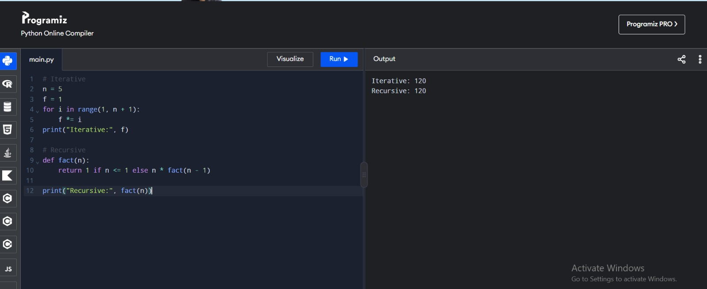

Experiment 4: Fibonacci Series
n = 6
a, b = 0, 1
f = []
for _ in range(n):
f.append(a)
a, b = b, a+b
print(f)
OUTPUT:
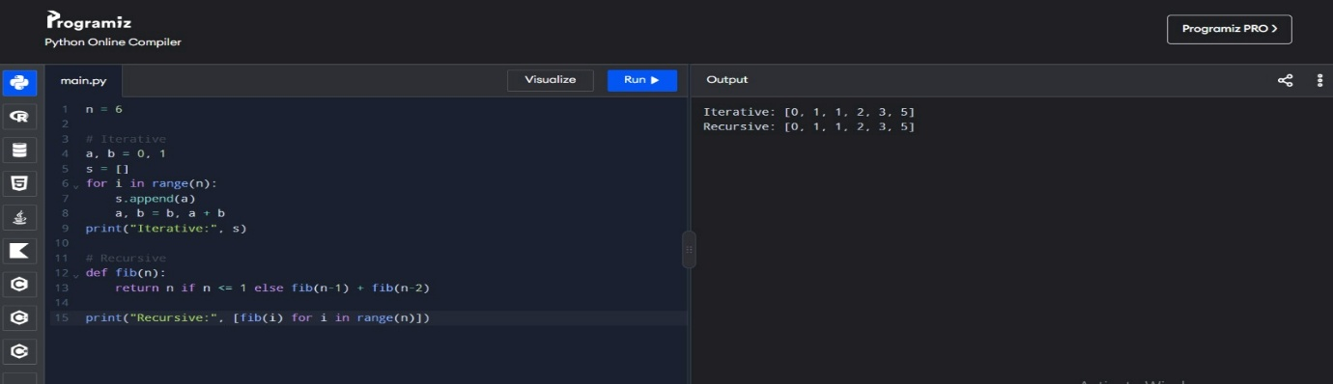
Experiment 5: Matrix Multiplication
A = [[1,2],[3,4]]
B = [[5,6],[7,8]]
C = [[sum(A[i][k]*B[k][j] for k in range(2)) for j in range(2)] for i in range(2)]
print(C)
OUTPUT: 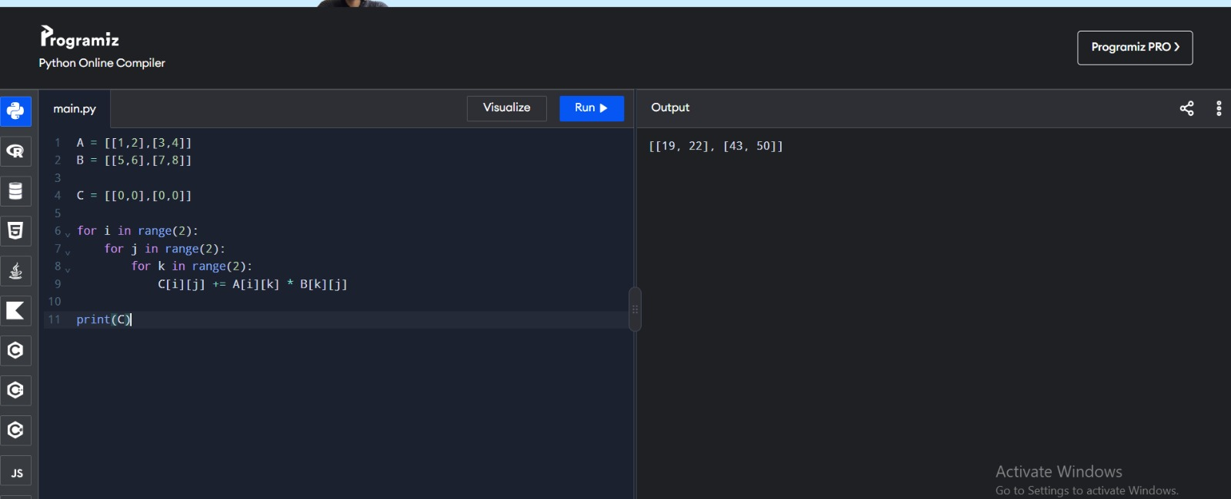
Experiment 6: Merge Sort
def merge(a):
if len(a) <= 1:
return a
m = len(a)//2
L, R = merge(a[:m]), merge(a[m:])
return sorted(L + R)
a = [38,27,43,3,9,82,10]
print(merge(a))
OUTPUT:
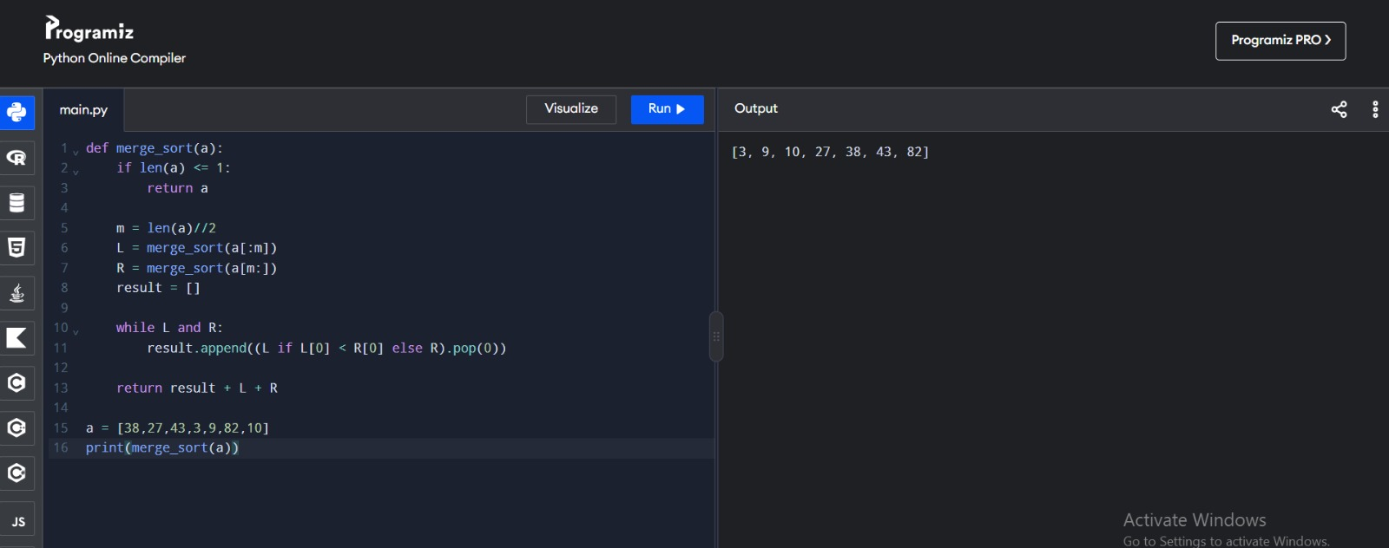

Experiment 7: Quick Sort
def quick(a):
if len(a) <= 1:
return a
p = a[0]
return quick([x for x in a[1:] if x <= p]) + [p] + quick([x for x in a[1:] if x > p])
a = [10,7,8,9,1,5]
print(quick(a))

OUTPUT:
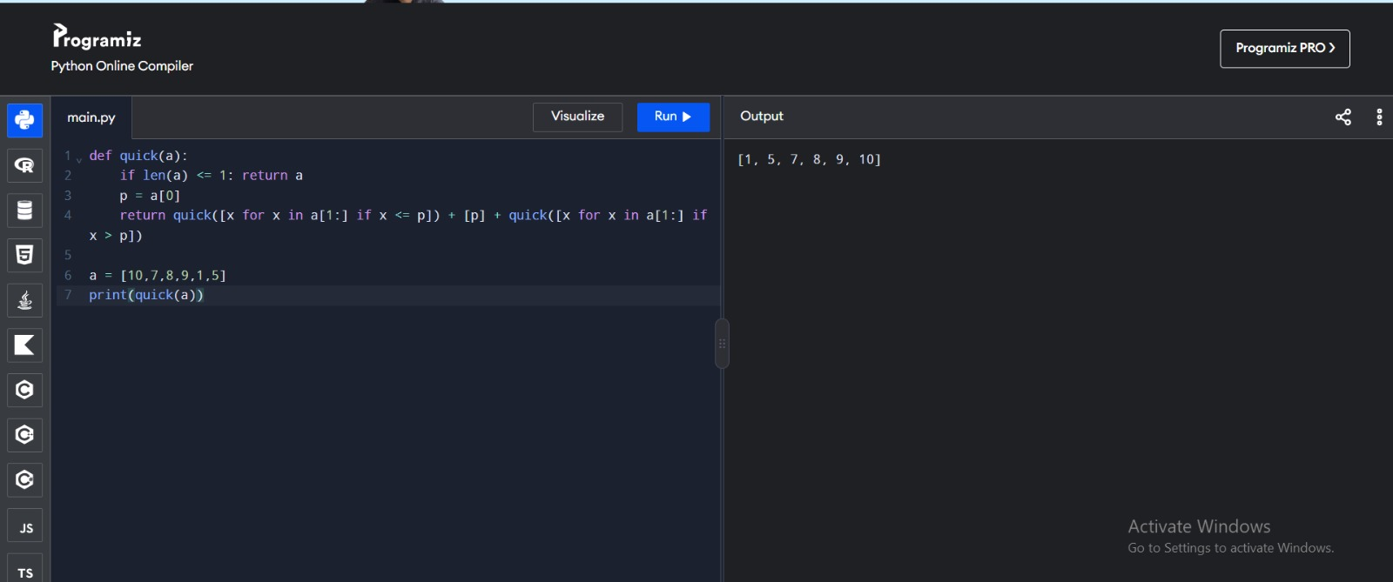
Experiment 8: Tower of Hanoi
def hanoi(n, a, b, c):
if n:
hanoi(n-1, a, c, b)
print(a, "->", c)
hanoi(n-1, b, a, c)
hanoi(3, 'A', 'B', 'C')
OUTPUT:
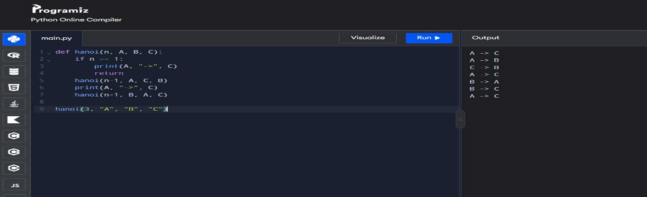

Experiment 9: GCD – Euclidean Algorithm
def gcd(a, b):
return a if b == 0 else gcd(b, a % b)
print(gcd(48, 18))
OUTPUT:
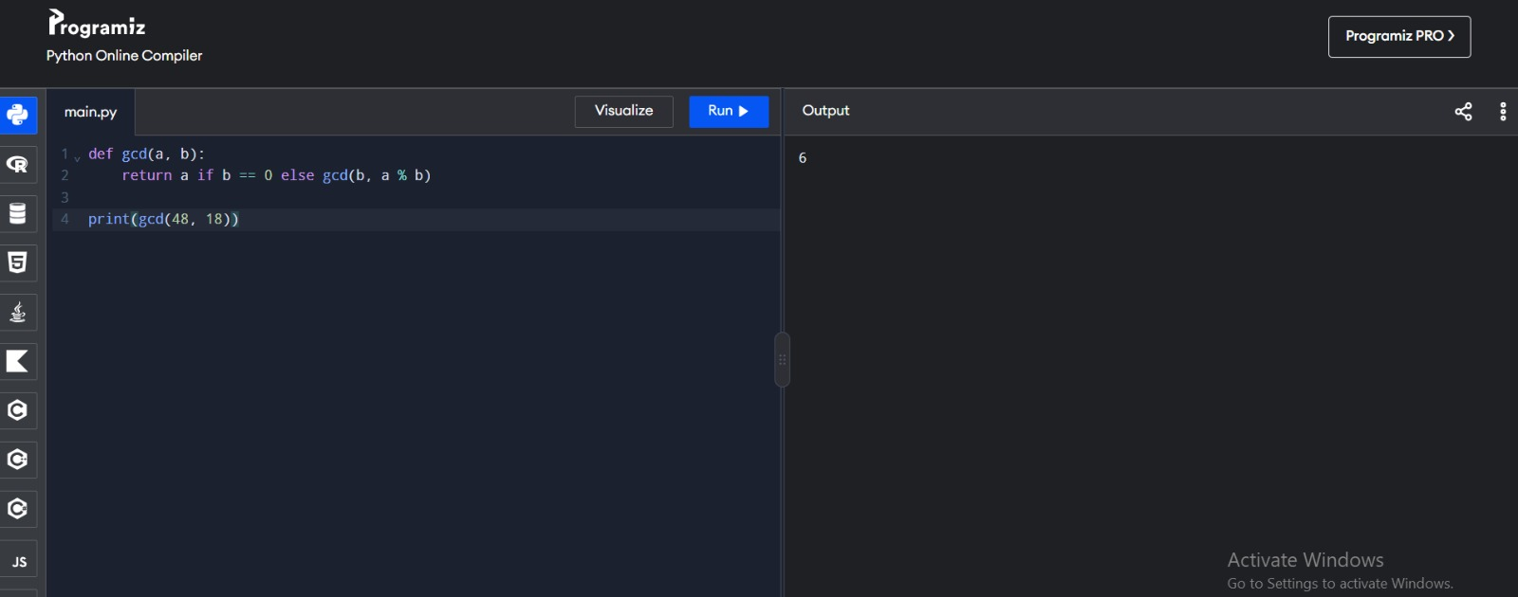
Experiment 10: Insertion Sort
a = [12,11,13,5,6]
for i in range(1,len(a)):
x = a[i]
j = i-1
while j >= 0 and a[j] > x:
a[j+1] = a[j]
j -= 1
a[j+1] = x
print(a)
OUTPUT:
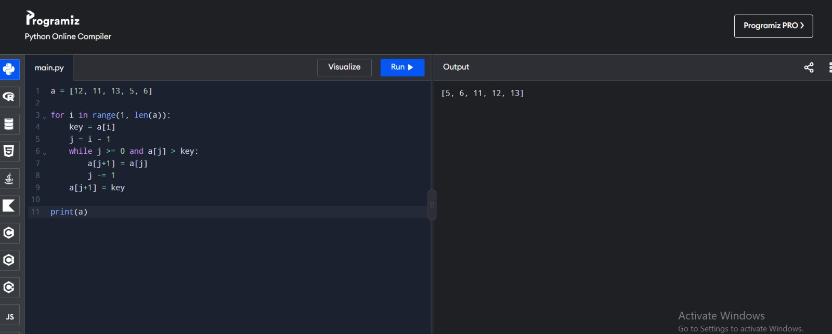

Experiment 11: Heap Sort
import heapq
a = [4,10,3,5,1]
heapq.heapify(a)
print([heapq.heappop(a) for _ in range(len(a))])
OUTPUT:
Experiment 12: Counting Inversions
a = [2,4,1,3,5]
c = sum(a[i] > a[j] for i in range(len(a)) for j in range(i+1,len(a)))
print(c)
OUTPUT:
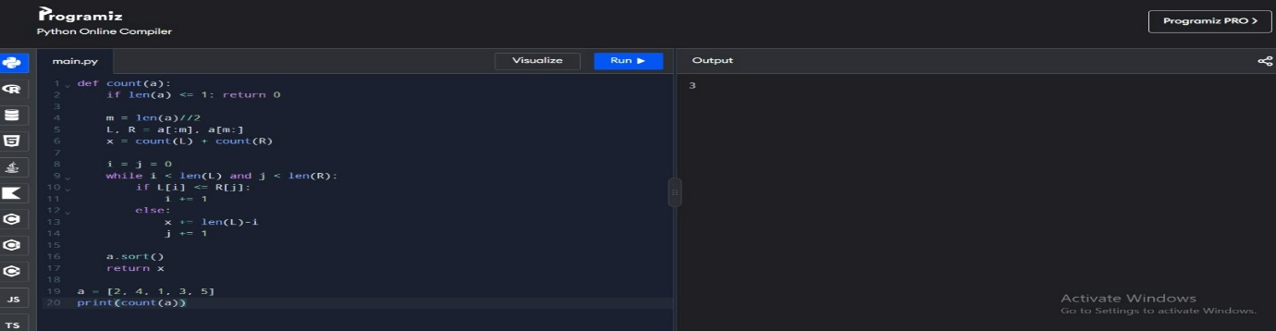

Experiment 13: Maximum Subarray Sum
a = [-2,-3,4,-1,-2,1,5,-3]
s = m = a[0]
for x in a[1:]:
s = max(x, s+x)
m = max(m, s)
print(m)
OUTPUT:
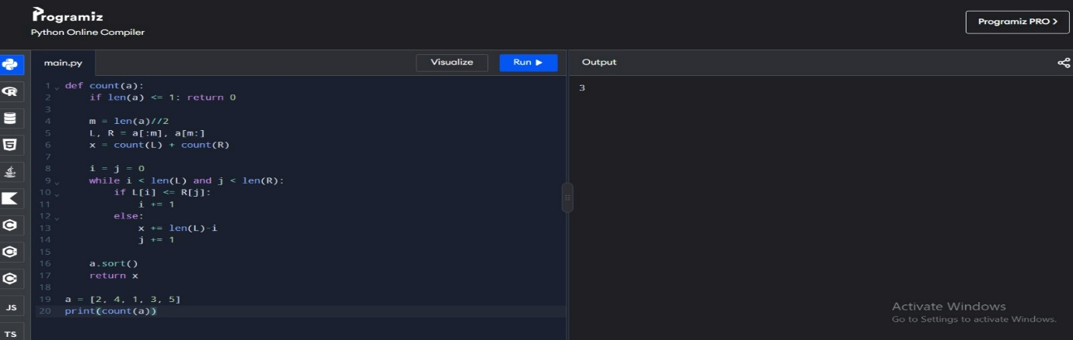
Experiment 14: Exponentiation
def power(x,n):
if n == 0:
return 1
y = power(x,n//2)
return y*y if n%2 == 0 else x*y*y
print(power(2,10))
OUTPUT:
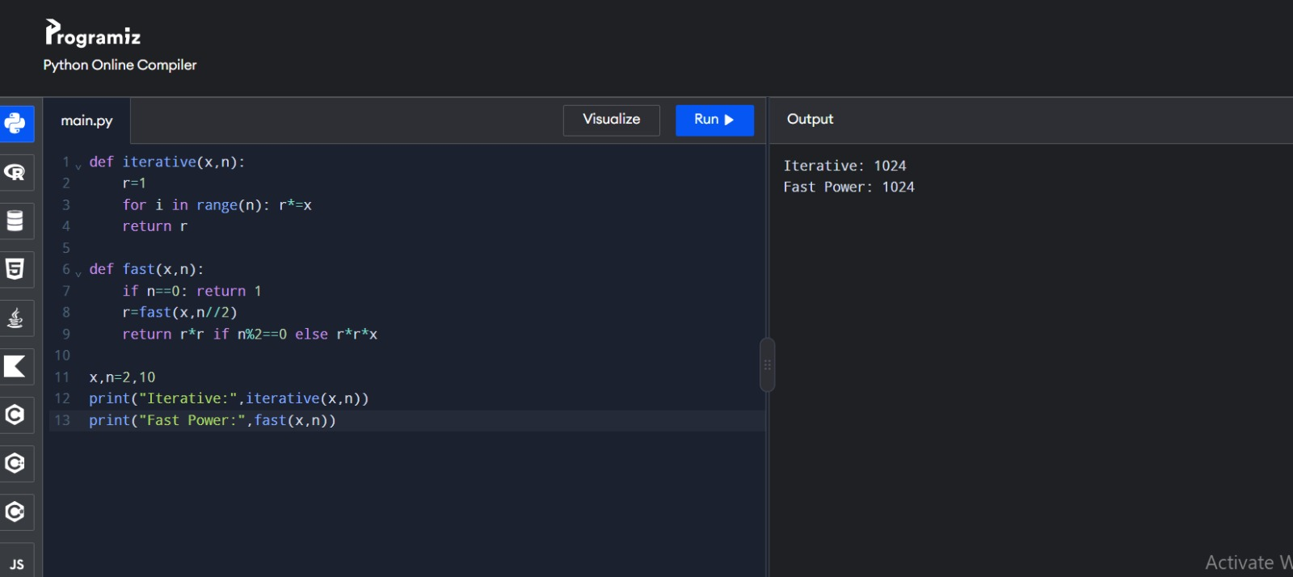

Experiment 15: Closest Pair of Points
from math import dist
p = [(1,2),(4,5),(7,8),(3,1)]
q = min(((p[i],p[j]) for i in range(len(p)) for j in range(i+1,len(p))),
key=lambda x: dist(*x))
print("Closest pair", q, "Distance =", dist(*q))
OUTPUT:
